MEDIUM LEVEL QUESTIONS
1. Write a program to count all the prime and composite numbers entered by the user.
Sample Input:
Enter the numbers
4
54
29
71
7
59
98
23
Sample Output:
Composite number:3
Prime number:5
Test cases:
1. 33, 41, 52, 61,73,90
2. TEN, FIFTY, SIXTY-ONE, SEVENTY-SEVEN, NINE
3. 45, 87, 09, 5.0 ,2.3, 0.4
4. -54, -76, -97, -23, -33, -98
5. 45, 73, 00, 50, 67, 44
CODE:
import java.util.*;
public class PrimeCompositeCount {
public static boolean isPrime(int n) {
if (n <= 1)
return false;
for (int i = 2; i <= Math.sqrt(n); i++) {
if (n % i == 0)
return false;
}
return true;
}

public static void main(String[] args) {
Scanner sc = new Scanner(System.in);
int prime = 0, composite = 0;
System.out.print("Enter number of elements: ");
int n = sc.nextInt();
System.out.println("Enter the numbers:");
for (int i = 0; i < n; i++) {
if (!sc.hasNextInt()) {
System.out.println("Invalid input");
return;
}
int num = sc.nextInt();
if (num > 1) {
if (isPrime(num))
prime++;
else
composite++;
}
}
System.out.println("Composite number: " + composite);
System.out.println("Prime number: " + prime);
}
}
OUTPUT:
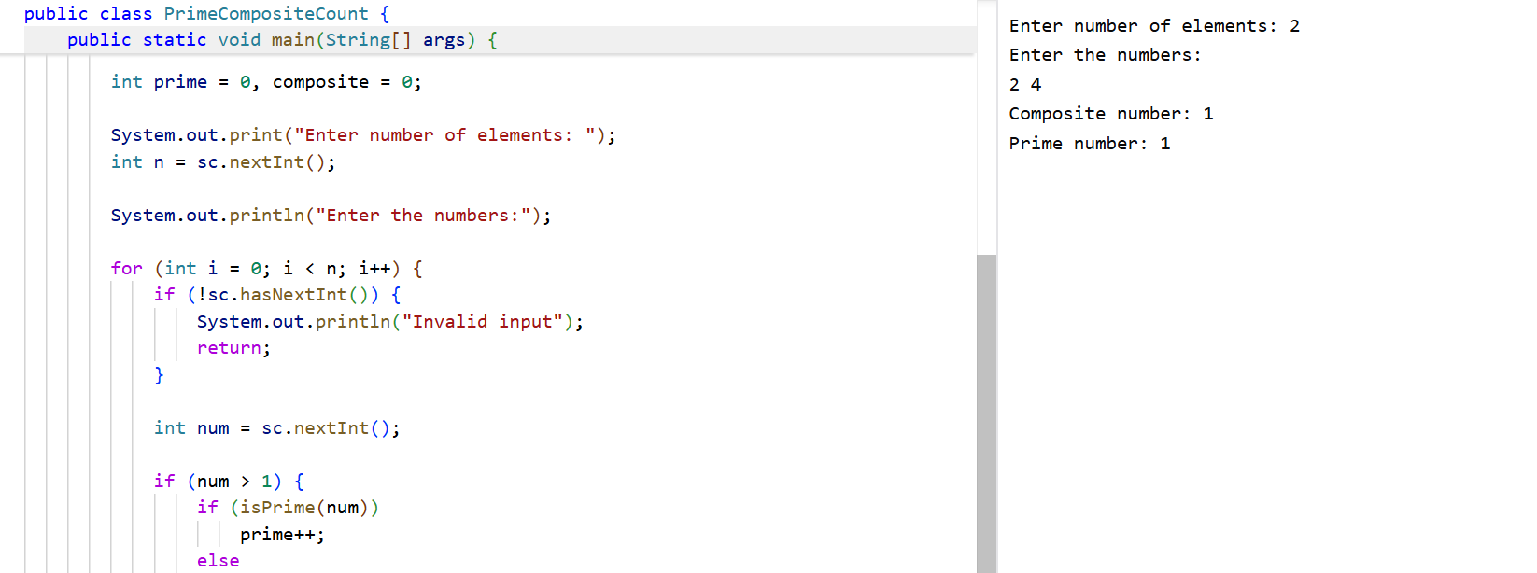

2. Find the M th maximum number and N th minimum number in an array and then find the
sum of it and difference of it.
Sample Input:
Array of elements = {14, 16, 87, 36, 25, 89, 34}
M = 1
N = 3
Sample Output:
1 st Maximum Number = 89
3 rd Minimum Number = 25
Sum = 114
Difference = 64
Test cases:
1. {16, 16, 16 16, 16}, M = 0, N = 1
2. {0, 0, 0, 0}, M = 1, N = 2
3. {-12, -78, -35, -42, -85}, M = 3 , N = 3
4. {15, 19, 34, 56, 12}, M = 6 , N = 3
5. {85, 45, 65, 75, 95}, M = 5 , N = 7
CODE:
import java.util.*;
public class MthMaxNthMin {
public static void main(String[] args) {
Scanner sc = new Scanner(System.in);
System.out.print("Enter size of array: ");
int size = sc.nextInt();
if(size<=0){
System.out.println("Invalid array size");
return;
}

int arr[] = new int[size];
System.out.println("Enter array elements:");
for(int i=0;i<size;i++)
arr[i]=sc.nextInt();
Arrays.sort(arr);
System.out.print("Enter M: ");
int M=sc.nextInt();
System.out.print("Enter N: ");
int N=sc.nextInt();
if(M<=0 || N<=0 || M>size || N>size){
System.out.println("Invalid M or N");
return;
}
int max=arr[size-M];
int min=arr[N-1];
System.out.println(M+" Maximum Number = "+max);
System.out.println(N+" Minimum Number = "+min);
System.out.println("Sum = "+(max+min));
System.out.println("Difference = "+(max-min));
}
}
OUTPUT:
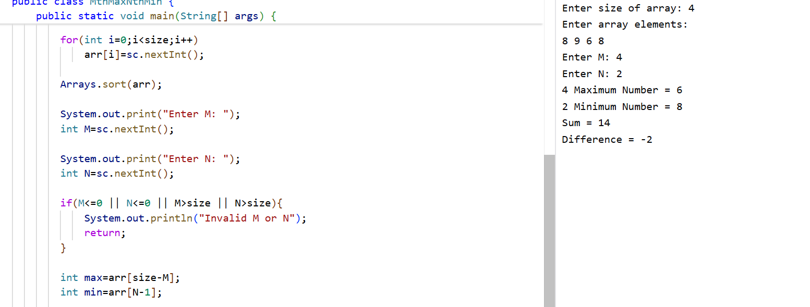

3. Write a program to print the total amount available in the ATM machine with the
conditions applied.
Total denominations are 2000, 500, 200, 100, get the denomination priority from the user
and the total number of notes from the user to display the total available balance to the
user
Sample Input:
Enter the 1 st Denomination: 500
Enter the 1 st Denomination number of notes: 4
Enter the 2 nd Denomination: 100
Enter the 2 nd Denomination number of notes: 20
Enter the 3 rd Denomination: 200
Enter the 3 rd Denomination number of notes: 32
Enter the 4 th Denomination: 2000
Enter the 4 th Denomination number of notes: 1
Sample Output:
Total Available Balance in ATM: 12400
Test Cases:
3 Hidden Test cases (Think Accordingly based on Denominations)
CODE:
import java.util.*;
public class ATMBalance {
public static void main(String[] args) {
Scanner sc = new Scanner(System.in);
int total = 0;
int valid[] = {100,200,500,2000};
for(int i=1;i<=4;i++){
System.out.print("Enter "+i+" Denomination: ");
int d=sc.nextInt();
boolean check=false;
for(int x:valid){
if(x==d){
check=true;
break;
}
}
if(!check){
System.out.println("Invalid Denomination");
return;
}
System.out.print("Enter number of notes: ");
int notes=sc.nextInt();
if(notes<0){
System.out.println("Invalid number of notes");
return;
}
total += d*notes;
}
System.out.println("Total Available Balance in ATM: "+total);

}
}
OUTPUT:
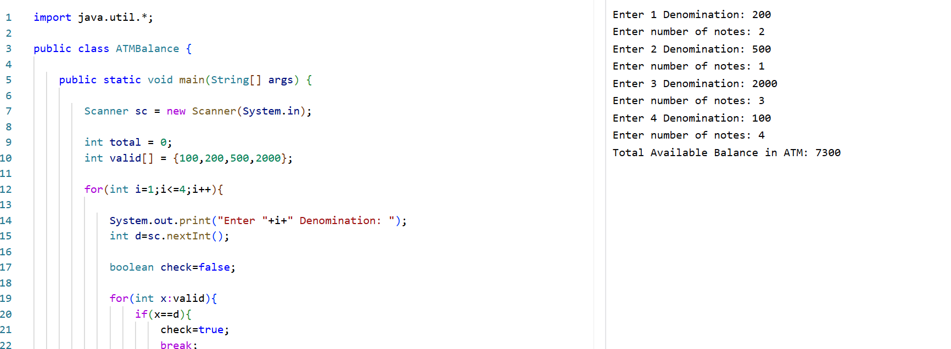
4. Write a program using choice to check
Case 1: Given string is palindrome or not
Case 2: Given number is palindrome or not
Sample Input:
Case = 1
String = MADAM
Sample Output:
Palindrome
Test cases:
1. MONEY
2. 5678765
3. MALAY12321ALAM
4. MALAYALAM
5. 1234.4321
CODE:
import java.util.*;
public class PalindromeChoice {
public static void main(String[] args) {
Scanner sc = new Scanner(System.in);
System.out.println("1.String");
System.out.println("2.Number");
System.out.print("Enter choice: ");
int choice=sc.nextInt();
switch(choice){
case 1:
System.out.print("Enter String: ");
String str=sc.next();
String rev="";
for(int i=str.length()-1;i>=0;i--)
rev+=str.charAt(i);
if(str.equals(rev))
System.out.println("Palindrome");
else
System.out.println("Not Palindrome");
break;
case 2:
System.out.print("Enter Number: ");
int num=sc.nextInt();
int temp=num;
int revNum=0;
while(num>0){
revNum=revNum*10+num%10;
num/=10;
}
if(temp==revNum)
System.out.println("Palindrome");
else
System.out.println("Not Palindrome");
break;
default:
System.out.println("Invalid Choice");
}
}
OUTPUT:
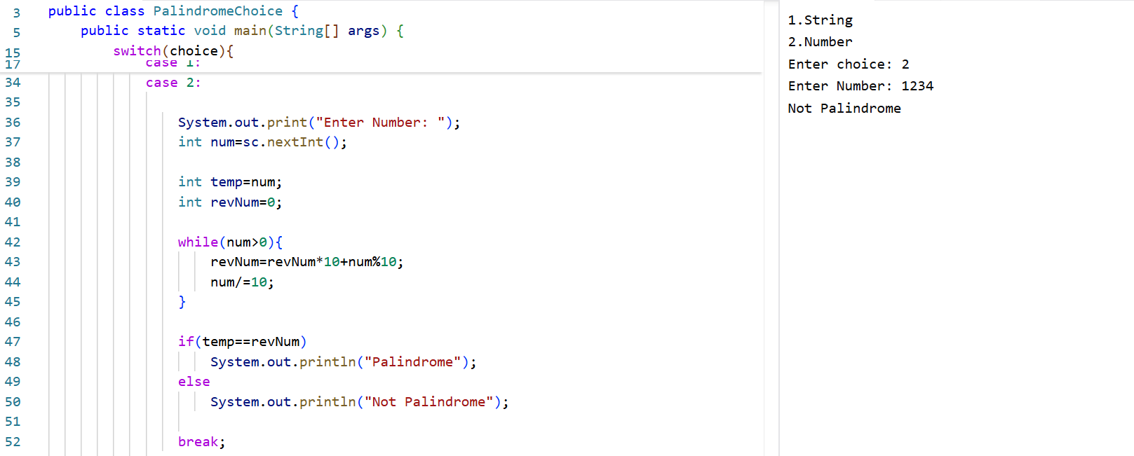
5. Write a program to convert Decimal number equivalent to Binary number and octal
numbers?
Sample Input:
Decimal Number: 15
Sample Output:
Binary Number = 1111
Octal = 17
Test cases:
1. 111
2. 15.2
3. 0
4. B12
5. 1A.2
CODE:
import java.util.*;
public class DecimalConversion {
public static void main(String[] args) {
Scanner sc = new Scanner(System.in);
System.out.print("Enter Decimal Number: ");
if(!sc.hasNextInt()){
System.out.println("Invalid Input");
return;
}
int num=sc.nextInt();
if(num<0){
System.out.println("Invalid Input");
return;
}
String binary=Integer.toBinaryString(num);
String octal=Integer.toOctalString(num);
System.out.println("Binary Number = "+binary);
System.out.println("Octal = "+octal);

}
}
OUTPUT:
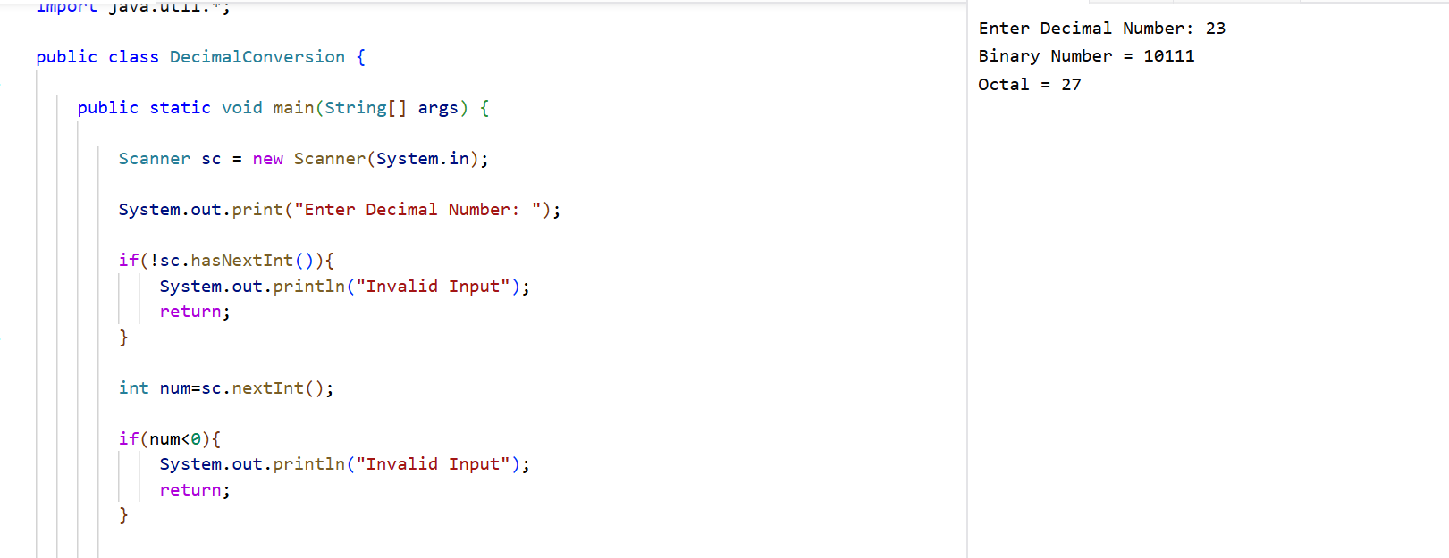
6. In an organization they decide to give bonus to all the employees on New Year. A 5%
bonus on salary is given to the grade A workers and 10% bonus on salary to the grade B
workers. Write a program to enter the salary and grade of the employee. If the salary of
the employee is less than $10,000 then the employee gets an extra 2% bonus on salary
Calculate the bonus that has to be given to the employee and print the salary that the
employee will get.
Sample Input &amp; Output:
Enter the grade of the employee: B
Enter the employee salary: 50000
Salary=50000
Bonus=5000.0
Total to be paid:55000.0
Test cases:
1. Enter the grade of the employee: A
Enter the employee salary: 8000
2. Enter the grade of the employee: C
Enter the employee salary: 60000
3. Enter the grade of the employee: B
Enter the employee salary: 0
4. Enter the grade of the employee: 38000
Enter the employee salary: A
5. Enter the grade of the employee: B
Enter the employee salary: -8000
CODE:
import java.util.*;
public class EmployeeBonus {
public static void main(String[] args) {
Scanner sc = new Scanner(System.in);
System.out.print("Enter the grade of the employee: ");
String grade = sc.next().toUpperCase();
System.out.print("Enter the employee salary: ");
if (!sc.hasNextDouble()) {
System.out.println("Invalid Salary Input");
return;
}
double salary = sc.nextDouble();
if (salary < 0) {
System.out.println("Salary cannot be negative");
return;
}
double bonusPercent = 0;
if (grade.equals("A"))
bonusPercent = 5;
else if (grade.equals("B"))
bonusPercent = 10;
else {
System.out.println("Invalid Grade");
return;
}

if (salary < 10000)
bonusPercent += 2;
double bonus = salary * bonusPercent / 100;
double total = salary + bonus;
System.out.println("Salary = " + salary);
System.out.println("Bonus = " + bonus);
System.out.println("Total to be paid = " + total);
}
}
OUTPUT:
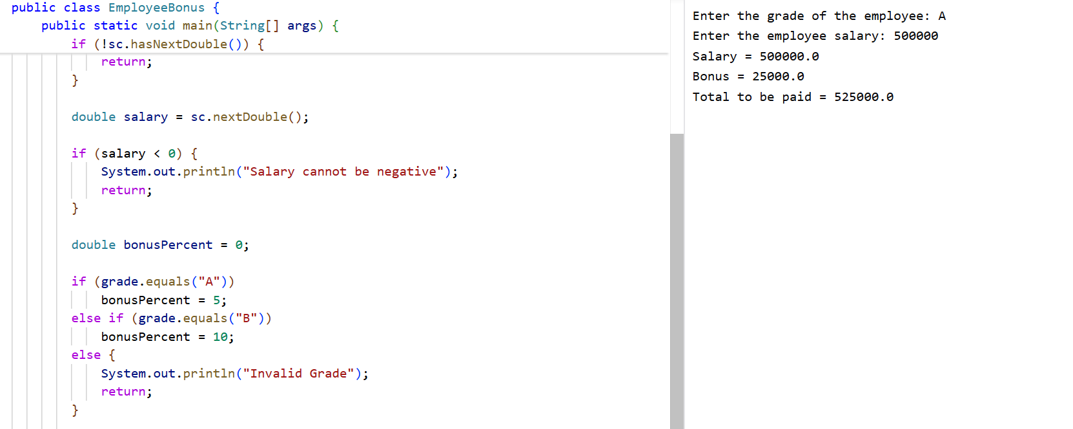

7. Write a program to print the first n perfect numbers. (Hint Perfect number means a
positive integer that is equal to the sum of its proper divisors)
Sample Input:
N = 3
Sample Output:
First 3 perfect numbers are: 6 , 28 , 496
Test Cases:
1. N = 0
2. N = 5
3. N = -2
4. N = -5
5. N = 0.2
CODE:
import java.util.*;
public class PerfectNumbers {
static boolean isPerfect(int n) {
int sum = 0;
for (int i = 1; i <= n / 2; i++) {
if (n % i == 0)
sum += i;
}
return sum == n;
}
public static void main(String[] args) {
Scanner sc = new Scanner(System.in);
System.out.print("Enter N: ");
if (!sc.hasNextInt()) {
System.out.println("Invalid Input");
return;
}
int n = sc.nextInt();
if (n <= 0) {
System.out.println("Invalid Input");
return;
}
int count = 0;
int num = 2;
System.out.print("First " + n + " perfect numbers are: ");
while (count < n) {

if (isPerfect(num)) {
System.out.print(num + " ");
count++;
}
num++;
}
}
}

OUTPUT:

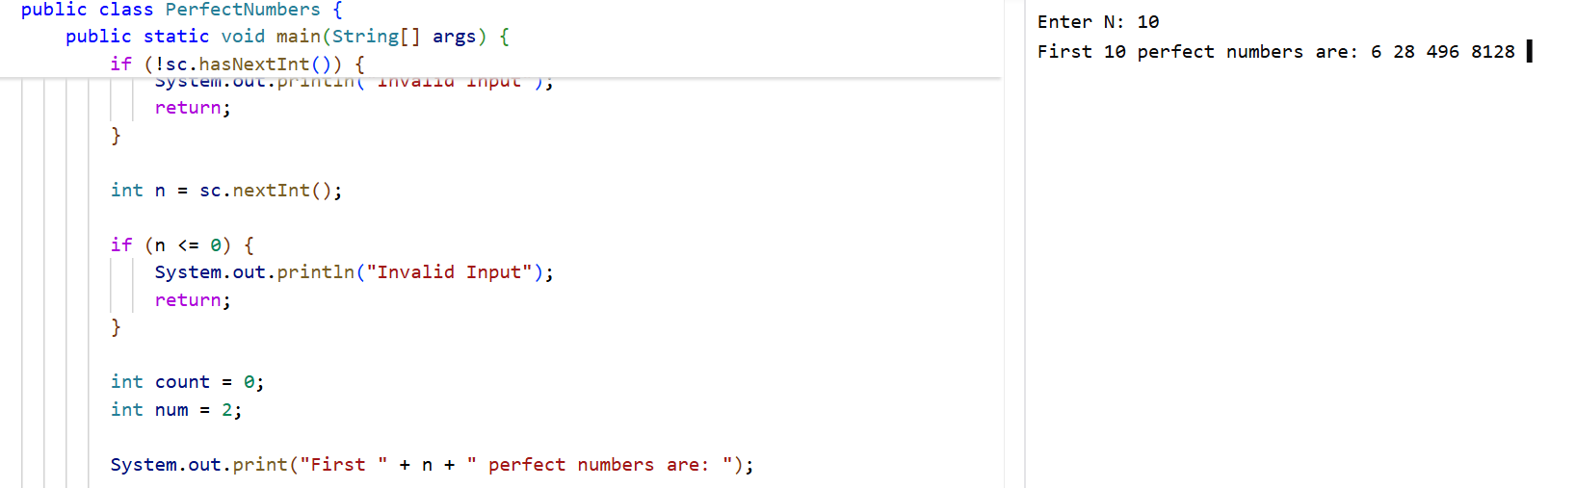
8. Write a program to enter the marks of a student in four subjects. Then calculate the total
and aggregate, display the grade obtained by the student. If the student scores an
aggregate greater than 75%, then the grade is Distinction. If aggregate is 60&gt;= and &lt;75,
then the grade is First Division. If aggregate is 50 &gt;= and &lt;60, then the grade is Second
Division. If aggregate is 40&gt;= and &lt;50, then the grade is Third Division. Else the grade is
Fail.
Sample Input &amp; Output:
Enter the marks in python: 90
Enter the marks in c programming: 91
Enter the marks in Mathematics: 92
Enter the marks in Physics: 93
Total= 366
Aggregate = 91.5
DISTINCTION
Test cases:
a) 18, 76,93,65
b) 73,78,79,75
c) 98,106,120,95
d) 96,73, -85,95
e) 78,59.8,76,79
CODE:
import java.util.*;
public class StudentGrade {
public static void main(String[] args) {
Scanner sc = new Scanner(System.in);
double marks[] = new double[4];
double total = 0;
String subjects[] = {
"Python",
"C Programming",
"Mathematics",
"Physics"
};
for (int i = 0; i < 4; i++) {
System.out.print("Enter marks in " + subjects[i] + ": ");
if (!sc.hasNextDouble()) {
System.out.println("Invalid Input");
return;
}
marks[i] = sc.nextDouble();

if (marks[i] < 0 || marks[i] > 100) {
System.out.println("Invalid Marks");
return;
}
total += marks[i];
}
double aggregate = total / 4;
System.out.println("Total = " + total);
System.out.println("Aggregate = " + aggregate);
if (aggregate >= 75)
System.out.println("DISTINCTION");
else if (aggregate >= 60)
System.out.println("FIRST DIVISION");
else if (aggregate >= 50)
System.out.println("SECOND DIVISION");
else if (aggregate >= 40)
System.out.println("THIRD DIVISION");
else
System.out.println("FAIL");
}
}
OUTPUT:
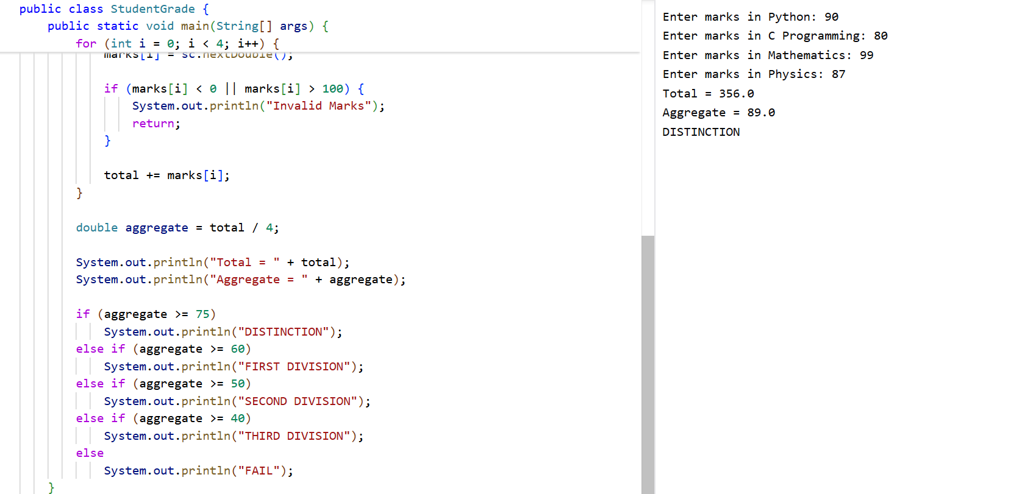

9. Write a program to read the numbers until -1 is encountered. Find the average of positive
numbers and negative numbers entered by user.
Sample Input:
Enter -1 to exit…
Enter the number: 7
Enter the number: -2
Enter the number: 9
Enter the number: -8
Enter the number: -6
Enter the number: -4
Enter the number: 10
Enter the number: -1
Sample Output:
The average of negative numbers is: -5.0
The average of positive numbers is : 8.66666667
Test cases:
1. -1,43, -87, -29, 1, -9
2. 73, 7-6,2,10,28,-1
3. -5, -9, -46,2,5,0
4. 9, 11, -5, 6, 0,-1
5. -1,-1,-1,-1,-1
CODE:
import java.util.*;
public class AveragePositiveNegative {
public static void main(String[] args) {
Scanner sc = new Scanner(System.in);
int positiveSum = 0;
int negativeSum = 0;
int positiveCount = 0;
int negativeCount = 0;

System.out.println("Enter -1 to exit");
while (true) {
System.out.print("Enter the number: ");
if (!sc.hasNextInt()) {
System.out.println("Invalid Input");
return;
}
int num = sc.nextInt();
if (num == -1)
break;
if (num >= 0) {
positiveSum += num;
positiveCount++;
} else {
negativeSum += num;
negativeCount++;
}
}
if (negativeCount > 0)
System.out.println("Average of negative numbers = "
+ (double) negativeSum / negativeCount);
else
System.out.println("No negative numbers");
if (positiveCount > 0)
System.out.println("Average of positive numbers = "
+ (double) positiveSum / positiveCount);
else
System.out.println("No positive numbers");
}
}

OUTPUT:
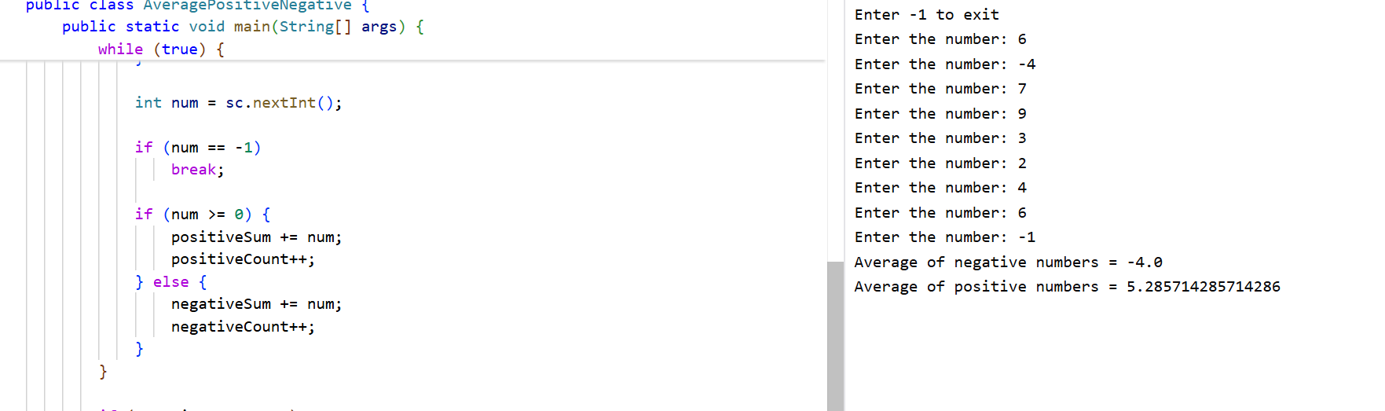

10. Write a program to read a character until a * is encountered. Also count the number of
uppercase, lowercase, and numbers entered by the users.
Sample Input:
Enter * to exit…
Enter any character: W
Enter any character: d
Enter any character: A
Enter any character: G
Enter any character: g
Enter any character: H
Enter any character: *
Sample Output:
Total count of lower case:2
Total count of upper case:4
Total count of numbers =0
Test cases:
1. 1,7,6,9,5
2. S, Q, l, K,7, j, M
3. M, j, L, &amp;, @, G
4. D, K, I, 6, L, *
5. *, K, A, e, 1, 8, %, *
CODE:
import java.util.*;
public class CharacterCount {
public static void main(String[] args) {
Scanner sc = new Scanner(System.in);
int upper = 0;
int lower = 0;
int digit = 0;
System.out.println("Enter * to exit");
while (true) {
System.out.print("Enter any character: ");
char ch = sc.next().charAt(0);
if (ch == '*')
break;
if (Character.isUpperCase(ch))
upper++;
else if (Character.isLowerCase(ch))
lower++;
else if (Character.isDigit(ch))
digit++;
}

System.out.println("Total count of lower case: " + lower);
System.out.println("Total count of upper case: " + upper);
System.out.println("Total count of numbers: " + digit);
}
}

OUTPUT:
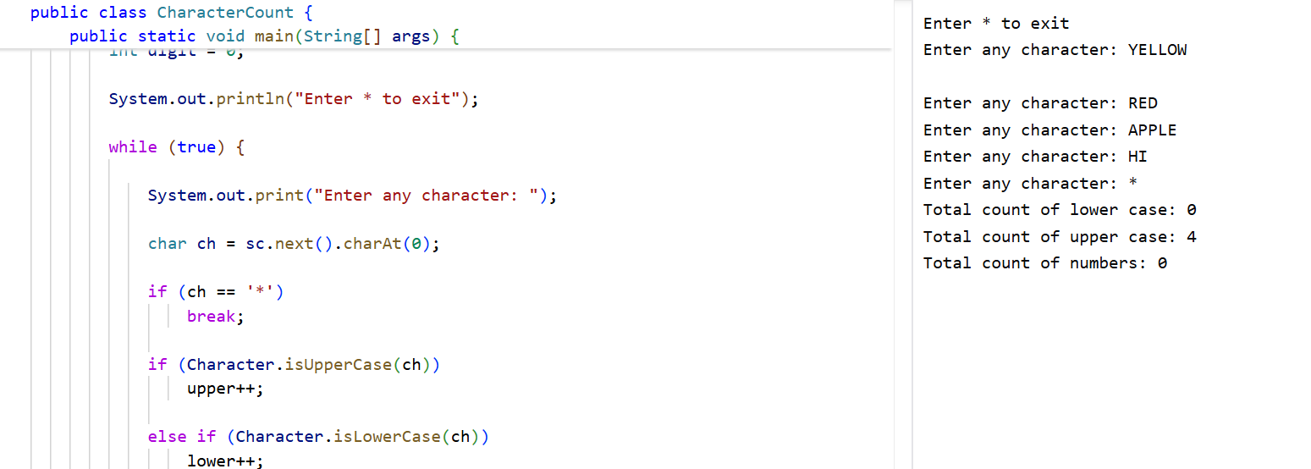
11. Write a program to calculate the factorial of number using recursive function.
Sample Input &amp; Output:
Enter the value of n: 6
Sample Input &amp; Output:
The factorial of 6 is: 720
Test cases:
1. N = 0
2. N = -5
3. N = 1
4. N = M
5. N = %
CODE:
import java.util.*;
public class RecursiveFactorial {
static long factorial(int n) {
if (n == 0 || n == 1)
return 1;
return n * factorial(n - 1);
}
public static void main(String[] args) {
Scanner sc = new Scanner(System.in);

System.out.print("Enter the value of n: ");
if (!sc.hasNextInt()) {
System.out.println("Invalid Input");
return;
}
int n = sc.nextInt();
if (n < 0) {
System.out.println("Factorial not possible for negative numbers.");
return;
}
System.out.println("The factorial of " + n + " is: " + factorial(n));
}
}
OUTPUT:
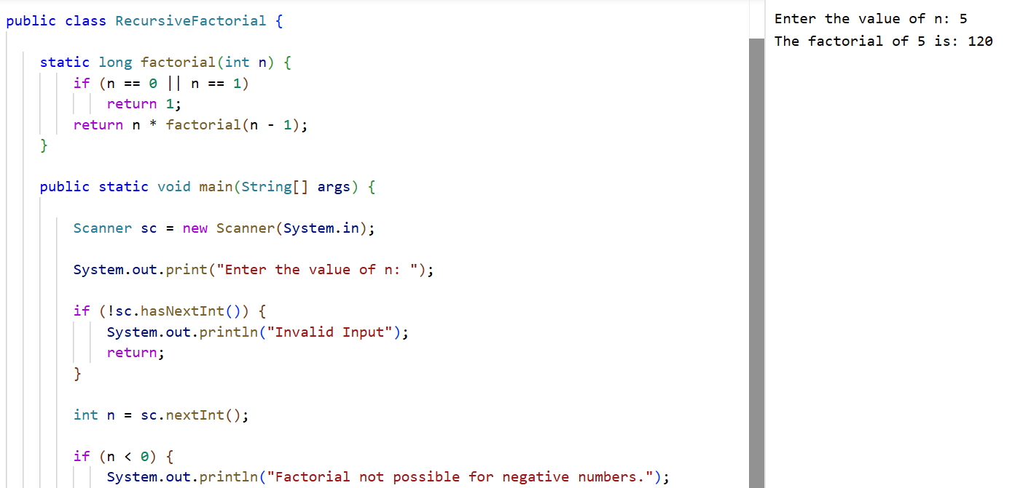
12. Write a Program to Find the Nth Largest Number in a array.
Sample Input:
List : {14, 67, 48, 23, 5, 62}
N = 4
Sample Output:
4 th Largest number: 23
Test cases:
1. N = 0
2. N = -5
3. N = 1
4. N = M
5. N = %
CODE:
import java.util.*;
public class NthLargest {
public static void main(String[] args) {
Scanner sc = new Scanner(System.in);
System.out.print("Enter the size of the array: ");
if (!sc.hasNextInt()) {
System.out.println("Invalid Input");
return;
}
int size = sc.nextInt();
if (size <= 0) {
System.out.println("Invalid Array Size");
return;
}
int arr[] = new int[size];
System.out.println("Enter array elements:");
for (int i = 0; i < size; i++)
arr[i] = sc.nextInt();
System.out.print("Enter N: ");
if (!sc.hasNextInt()) {
System.out.println("Invalid Input");
return;
}
int n = sc.nextInt();
if (n <= 0 || n > size) {
System.out.println("Invalid N");
return;
}
Arrays.sort(arr);
System.out.println(n + "th Largest Number: " + arr[size - n]);
}
}
OUTPUT:
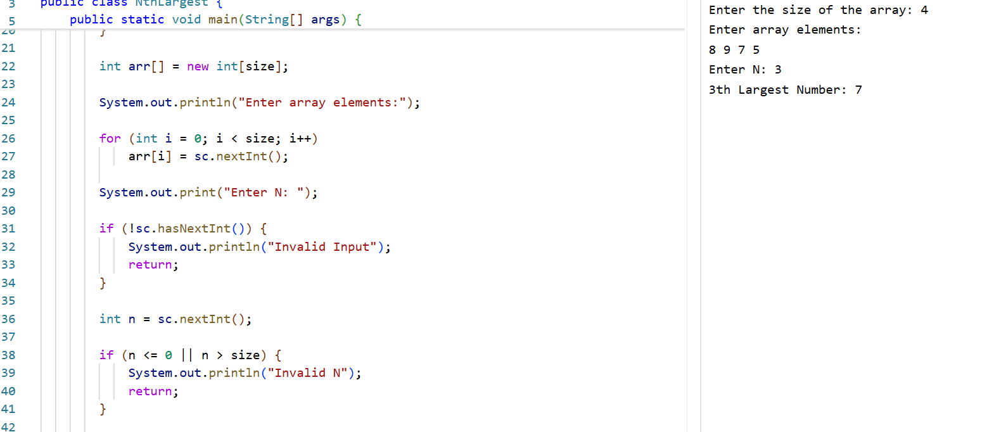
13. Write a program to convert the Binary to Decimal, Octal
Sample Input:
Given Number: 1101
Sample Output:
Decimal Number: 13
Octal:15
Test cases:
1. 211
2. 11011
3. 22122
4. 111011.011
5. 1010.0101
CODE:
import java.util.*;

public class BinaryConversion {
public static void main(String[] args) {
Scanner sc = new Scanner(System.in);
System.out.print("Enter Binary Number: ");
String binary = sc.next();
if (!binary.matches("[01]+")) {
System.out.println("Invalid Binary Number");
return;
}
int decimal = Integer.parseInt(binary, 2);
String octal = Integer.toOctalString(decimal);
System.out.println("Decimal Number: " + decimal);
System.out.println("Octal: " + octal);
}
}
OUTPUT:
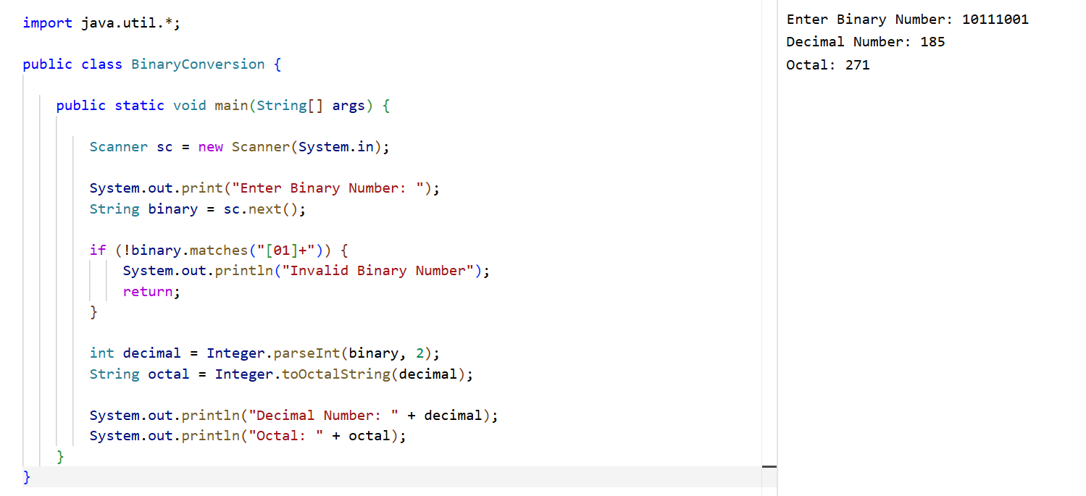
14. Write a program to find the number of special characters in the given statement
Sample Input:
Given statement: Modi Birthday @ September 17, #&amp;$% is the wishes code for him.
Sample Output:
Number of special Characters: 5
CODE:
import java.util.*;
public class SpecialCharacterCount {
public static void main(String[] args) {
Scanner sc = new Scanner(System.in);
System.out.println("Enter the statement:");
String str = sc.nextLine();
int count = 0;
for (int i = 0; i < str.length(); i++) {
char ch = str.charAt(i);
if (!Character.isLetterOrDigit(ch) && !Character.isWhitespace(ch))
count++;
}
System.out.println("Number of Special Characters: " + count);
}
}
OUTPUT:
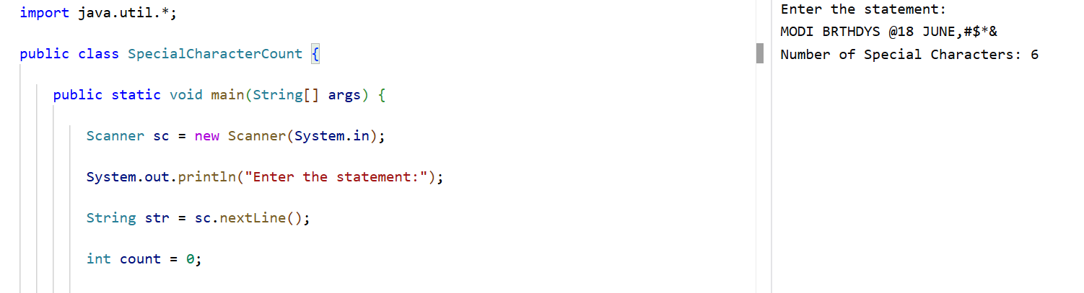
15. Write a Program to Remove the Duplicate Items from a array.
Sample Input:
Enter the number of elements in array:7
Enter element1:10
Enter element2:20
Enter element3:20
Enter element4:30
Enter element5:40
Enter element6:40
Enter element7:50
Sample Output:
Non-duplicate items:
[10, 20, 30, 40, 50]
CODE:
import java.util.*;
public class RemoveDuplicates {
public static void main(String[] args) {
Scanner sc = new Scanner(System.in);
System.out.print("Enter the number of elements: ");
if (!sc.hasNextInt()) {
System.out.println("Invalid Input");
return;
}
int n = sc.nextInt();
if (n <= 0) {
System.out.println("Invalid Array Size");
return;
}
LinkedHashSet<Integer> set = new LinkedHashSet<>();
System.out.println("Enter array elements:");
for (int i = 0; i < n; i++) {
set.add(sc.nextInt());
}
System.out.println("Non-duplicate items:");
System.out.println(set);
}
}

OUTPUT:
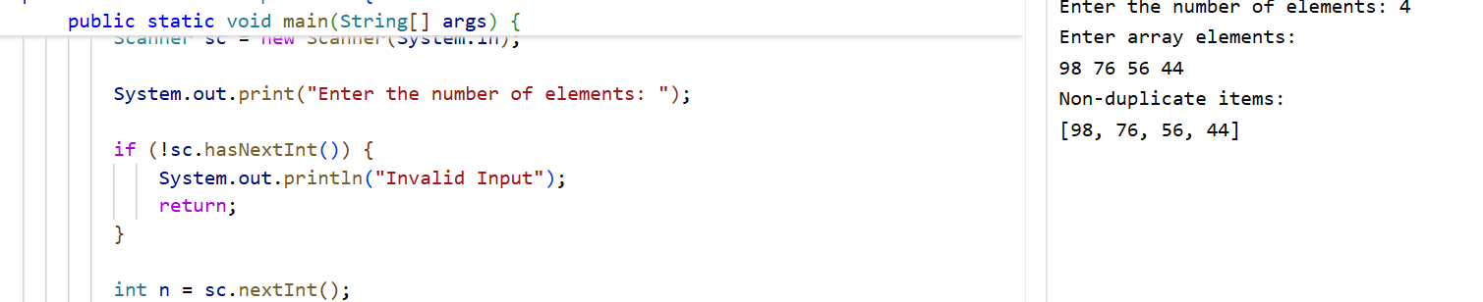
16. Bank is a class that provides method to get the rate of interest. But, rate of interest may
differ according to banks. For example, SBI, ICICI and AXIS banks are providing 8.4%,
7.3% and 9.7% rate of interest. Write a Java program for above scenario.
Sample Input SBI, 8.4
Sample Output
Test case
1. SBI, 8.3
2. ICICI, 7.3
3. AXIS, 9.7
4. SBI, 8.6
5. AXIX, 7.6
CODE:
class Bank {
double getRateOfInterest() {
return 0;
}
}
class SBI extends Bank {
double getRateOfInterest() {
return 8.4;
}
}
class ICICI extends Bank {
double getRateOfInterest() {
return 7.3;
}
}
class AXIS extends Bank {
double getRateOfInterest() {
return 9.7;
}
}
public class BankInterest {
public static void main(String[] args) {
SBI sbi = new SBI();
ICICI icici = new ICICI();
AXIS axis = new AXIS();
System.out.println("SBI Rate of Interest: " + sbi.getRateOfInterest() + "%");
System.out.println("ICICI Rate of Interest: " + icici.getRateOfInterest() + "%");
System.out.println("AXIS Rate of Interest: " + axis.getRateOfInterest() + "%");
}
}
OUTPUT:
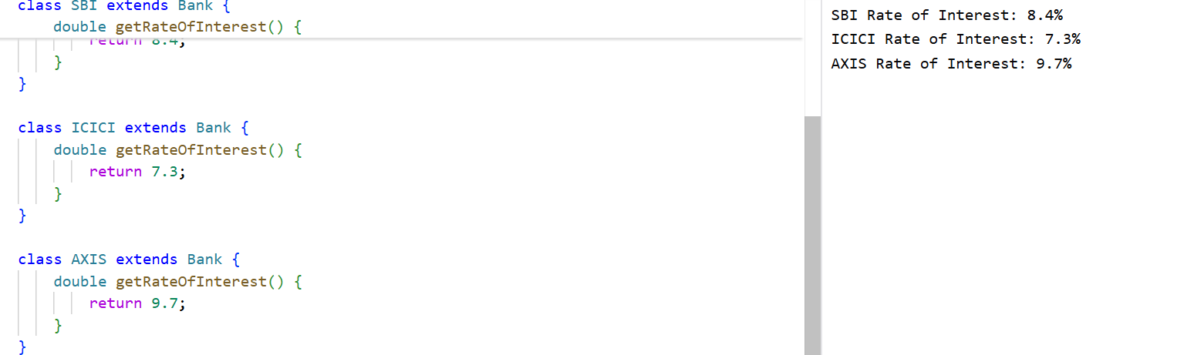
17. Bring out the situation in which member names of a subclass hide members by the same
name in the super class. How it can be resolved? Write Suitable code in Java and
Implement above scenario with the Parametrized Constructor (accept int type
parameter) of the Super Class can be called from Sub Class Using super () and display
the input values provided.
Sample Input : 100, 200
Sample Output : 100, 200
Test Cases
1. 10, 20
2. -20, -30
3. 0, 0
4. EIGHT FIVE
5. 10.57, 12.58
CODE:
import java.util.*;
class SuperClass {
int a;
SuperClass(int a) {
this.a = a;
}
}
class SubClass extends SuperClass {
int b;
SubClass(int a, int b) {
super(a);
this.b = b;
}
void display() {
System.out.println("Value 1 = " + a);
System.out.println("Value 2 = " + b);
}
}
public class SuperDemo {
public static void main(String args[]) {
Scanner sc = new Scanner(System.in);
System.out.print("Enter first value: ");
int x = sc.nextInt();
System.out.print("Enter second value: ");
int y = sc.nextInt();

SubClass obj = new SubClass(x, y);
obj.display();
}
}
OUTPUT:
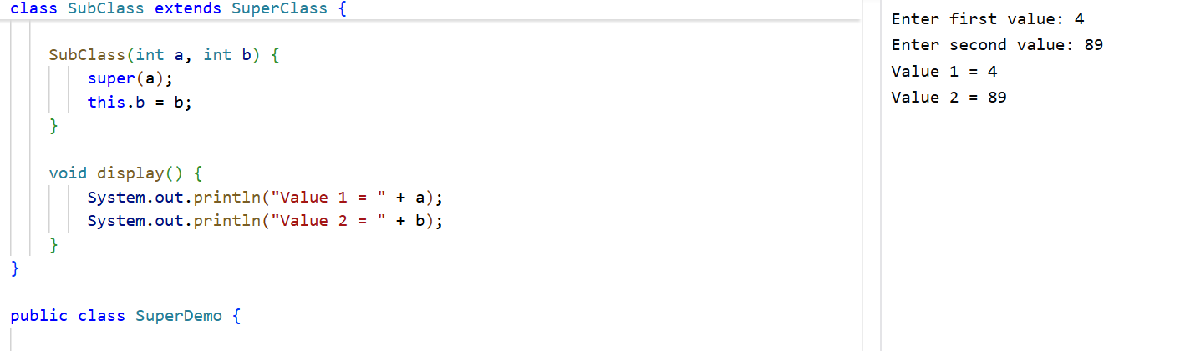

18. Display Multiplication table for 5 and 10 using various stages of life cycle of the thread
by generating a suitable code in Java.
Sample Input 5, 10
5 X 1 = 5
5 X 2 =10
….
10 X 1 =10
10 X 2 = 20
….
Test Cases:
1. 10, 20
2. -10, -30
3. 0, 0
4. SIX, SIX
5. 9.8, 9.6
CODE:
class Table extends Thread {

int num;
Table(int num) {
this.num = num;
}
public void run() {
for (int i = 1; i <= 10; i++) {
System.out.println(num + " x " + i + " = " + (num * i));
}
}
}
public class ThreadTable {
public static void main(String args[]) {
Table t1 = new Table(5);
Table t2 = new Table(10);
t1.start();
try {
t1.join();
} catch (Exception e) {
}
t2.start();
}
}

OUTPUT:
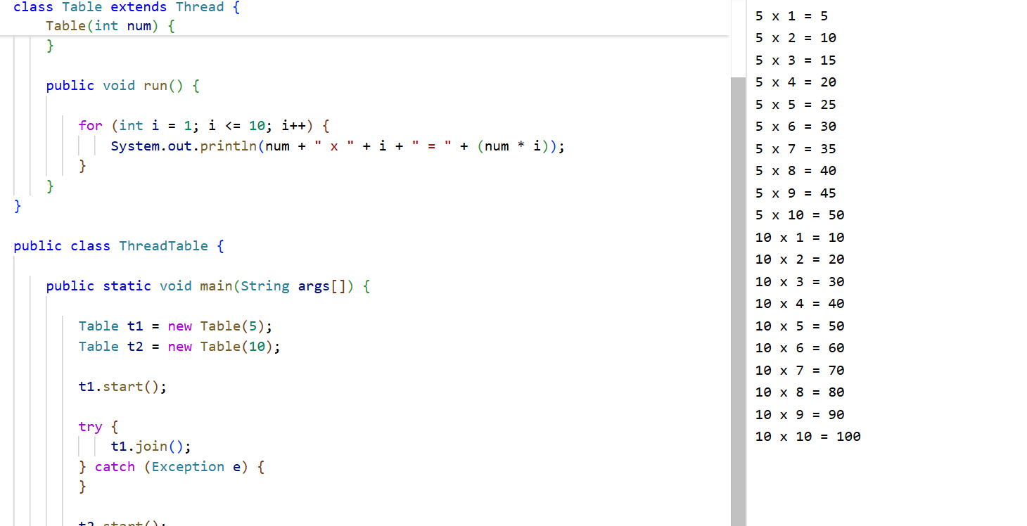
19. Using the concepts of thread with implementing Runnable interface in Java to generate
Fibonacci series.
Sample Input : 5
Sample Output : 0 1 1 2 3 …..
Test Cases
1. 7
2. -10
3. 0
4. EIGHT FIVE
5. 12.65
CODE:
import java.util.*;
class Fibonacci implements Runnable {
int n;
Fibonacci(int n) {
this.n = n;
}
public void run() {

if (n <= 0) {
System.out.println("Invalid Input");
return;
}
int a = 0;
int b = 1;
System.out.print("Fibonacci Series: ");
for (int i = 1; i <= n; i++) {
System.out.print(a + " ");
int c = a + b;
a = b;
b = c;
}
}
}
public class RunnableDemo {
public static void main(String args[]) {
Scanner sc = new Scanner(System.in);
System.out.print("Enter N: ");
int n = sc.nextInt();
Thread t = new Thread(new Fibonacci(n));
t.start();
}
}
OUTPUT:
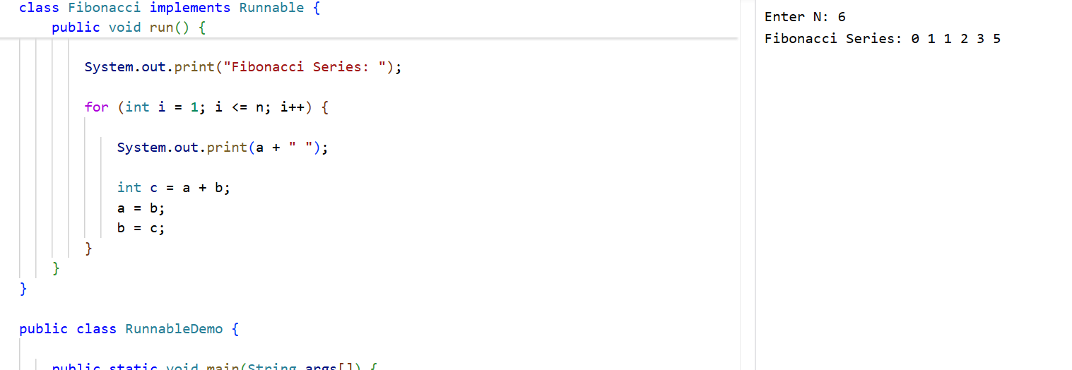

20. Generate a Java code to find the sum of N numbers using array and throw
ArrayIndexOutOfBoundsException when the loop variable beyond the size N.
Sample Input : 5
1 2 3 4 5
Sample Output : 15
Test Cases
1. 4, 10
2. -10
3. 0
4. EIGHT SEVEN
5. 12.68
CODE:
import java.util.*;
public class ArrayException {
public static void main(String args[]) {
Scanner sc = new Scanner(System.in);
System.out.print("Enter N: ");
int n = sc.nextInt();
if (n <= 0) {
System.out.println("Invalid Input");
return;
}
int arr[] = new int[n];
int sum = 0;
System.out.println("Enter array elements:");
for (int i = 0; i < n; i++) {
arr[i] = sc.nextInt();
}
try {
for (int i = 0; i <= n; i++) {
sum += arr[i];
}
} catch (ArrayIndexOutOfBoundsException e) {

System.out.println("ArrayIndexOutOfBoundsException Caught");
}
System.out.println("Sum = " + sum);
}
}
OUTPUT:
